DOORI

A PROJECT REPORT

Submitted by

Vardaan Vishnu (19BCE10063)
Prantik Bhattacharjee(19BCE10222)
Shikhar Vashishta (19BCE10025)
Prashant Chauhan (19BCE10280)

in partial fulfillment for the award of the degree
of

BACHELOR OF TECHNOLOGY

in

COMPUTER SCIENCE AND ENGINEERING


SCHOOL OF COMPUTING SCIENCE AND ENGINEERING
VIT BHOPAL UNIVERSITY
KOTHRIKALAN, SEHORE
MADHYA PRADESH - 466114

Apr 2021

VIT BHOPAL UNIVERSITY,KOTHRIKALAN, SEHORE
MADHYA PRADESH – 466114

BONAFIDE CERTIFICATE

Certified that this project report titled Doori is the Bonafide work of Vardaan Vishnu (19BCE10063), Prantik Bhattacharjee (19BCE10222), Shikhar Vashishtha (19BCE10025), Prashant Chauhan(19BCE10280) who carried out the project work under my supervision. Certified further that to the best of my knowledge the work reported here does not form part of any other project / research work on the basis of which a degree or award was conferred on an earlier occasion on this or any other candidate.

PROGRAM CHAIR PROJECT GUIDE
Dr. M Ashwin, Program Chair Dr Abha Trivedi,
School of Computer Science and Engineering School of Computer Science and Engineering
VIT BHOPAL UNIVERSITY VIT BHOPAL UNIVERSITY

The Project Exhibition II Examination is held on 30 April 2021

ACKNOWLEDGEMENT

First and foremost, we would like to thank the Lord Almighty for His presence and immense blessings throughout the project work.
We wish to express our heartfelt gratitude to Dr. Manas Kumar Mishra, Head of the Department, School of Computer Science & Engineering for much of his valuable support encouragement in carrying out this work.
We would like to thank our internal guide Dr. Abha Trivedi, for continually guiding and actively participating in our project, giving valuable suggestions to complete the project work.
We would like to thank all the technical and teaching staff of the School of Computer Science & Engineering, who extended directly or indirectly all support.
Last, but not the least, we are deeply indebted to our parents who have been the greatest support while we worked day and night for the project to make it a success.

ABSTRACT

Anon is a typically developed app created by us which aims for the safety and security of information. Actually, it is developed in such a way that in the mode of communication, no data is leaked and the work can be accomplished without having much information getting shown to the person you are chatting. (For e.g.- displaying profile picture or the name showing the WhatsApp without saving the number). It is only used for exchanging messages in WhatsApp only. We have ideas for using API (application programming interface) provided by WhatsApp public on its website. Our app ANON has two versions, one for the app and that will require a mobile device to operate. The second version is that of a web version (WhatsApp Web) that will require a laptop or a desktop to operate. We used HTML & CSS for implementing the app and its features. We wish to make changes in the coming future with new features of our app as WhatsApp gets updated from time to time.
The various features we wish to add to our app are:
- Messaging in WhatsApp, without saving contact info
- Temporarily saving contact info within app for later use
- Ability to backup chats with unknown contacts

TABLE OF CONTENTS

CHAPTER NO. | TITLE | PAGE NO.
 | Abstract | 3
1 | INTRODUCTION  Introduction  1.2 Existing work, limitations  1.3 Proposed work for project  1.4 Novelty of Project | 6  .  .  .
2 | PROJECT LITERATURE REVIEW  2.1 Real Time Usage of Project  2.2 Real World Hardware and Software Requirements | 7
3 | WORK DONE  3.1 Module Work Flow  3.2 Overall System Architecture  3.3 Module Description  3.4 Implementation and Coding (Images) | 8  9  9  9,10,11

INTRODUCTION

  - PROJECT INTRODUCTION: -

Anon aims to be a kind of app that will facilitate WhatsApp Messaging and WhatsApp Calling without having to save the recipients contact info
This idea originates from people’s need for quick messaging to unknown contacts, on the go!
  - EXISTING WORK, LIMITATIONS: -
ANON is easy to use. The thing that makes it attractive is its ease of use, free of
cost. It can serve as a great platform for some humanitarian purposes without
any threat to privacy. For instance – Raising of social issues, counselling
purpose, communication with senior citizens etc.

There can be limitation also with its use: -
People often doubt for it add less service, making them think about threat of
Data Security.

People might misuse it for spamming unknown contacts.

  - PROPOSED WORK FOR PROJECT: -

The various features we wish to add to our app are:
- Messaging in WhatsApp, without saving contact info
- Temporarily saving contact info within app for later use
- Ability to backup chats with unknown contacts

  - NOVELTY OF PROJECT
- The Idea for this project arises from ‘WhatsApp public API documentation’ which stated an API that could create chat links with a given Contact
- Novelty or Originality of concept remains the essence of this project
- We will try to make our project as Original & Innovative as possible by constantly adding our own innovative ideas

PROJECT LITERATURE REVIEW

(2.1) REAL TIME USAGE: -
How our app can be used in real time scenario:
1. We being students can send any assignment or tutorial related work to anyone without saving the number as our app is meant for these purposes only.
2. When WhatsApp will start digital transfer of money, then we can transfer money without saving the contact info, for faster transactions.

(2.2) REAL WORLD HARDWARE AND SOFTWARE REQUIREMENTS: -
Hardware Requirements-
- Our app ANON will require a mobile device to operate
- The web version (WhatsApp Web) that will require a laptop or a desktop to operate
Software Requirements-
- ANON uses API 24 & above thus requires Android Operating System newer than Marshmallow 5.1 upto Android 11
- We can use any browser that can run latest HTML & CSS scripts

WORK DONE

(3.1) MODULE WORK FLOW: -

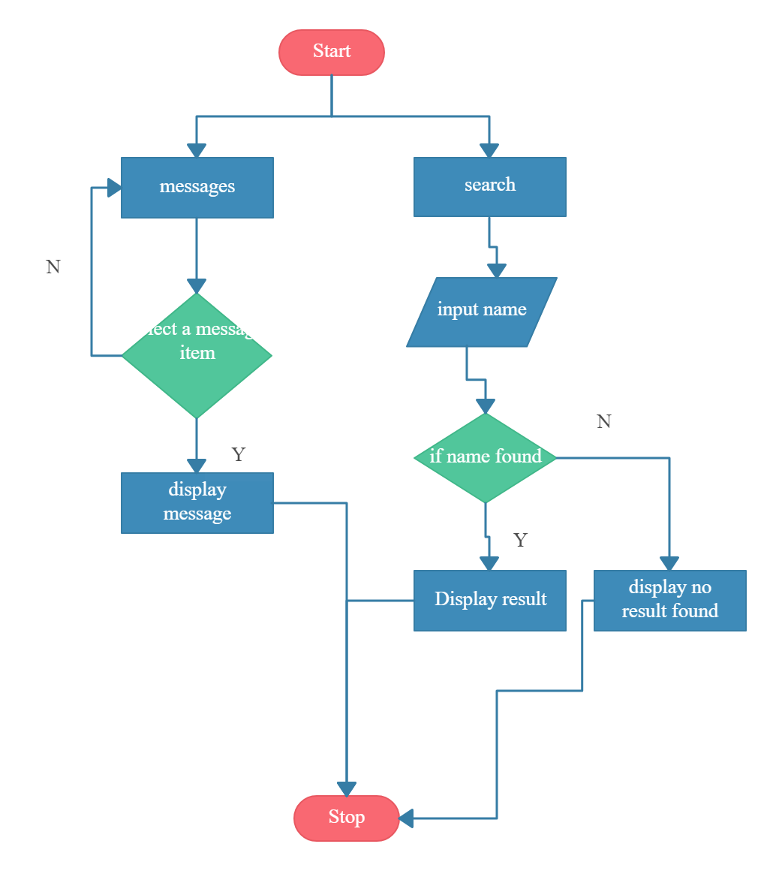

(3.2) OVERALL SYSTEM ARCHITECTURE: -
- WhatsApp server is almost completely implemented in Erlang.
- Server systems that do the backend message routing are done in Erlang.
- Great achievement is that the number of active users is managed with a really small server footprint. Team consensus is that it is largely because of Erlang.
- WhatsApp server has started from ejabberd
- Ejabberd is a famous open source Jabber server written in Erlang.
- To handle 50 billion messages a day the focus is on making a reliable system that works. Monetization is something to look at later, it’s far down the road.

(3.3) MODULE DESCRIPTION: -
- Type the number whom you want to send the SMS with country code, through WhatsApp Web or Android app.
- WhatsApp public API is called in the application.
- Server systems do the backend message routing.
- WhatsApp server start from ejabberd, a famous open source server.
- The successful retrieval of a message is sent back to the WhatsApp server which forwards this status back to the original sender
- Material Design Lite Library is used in this app which lets us add a Material Design look and aims to optimize for cross-device use

(3.4) IMPLEMENTATION & CODING (IMAGES): -
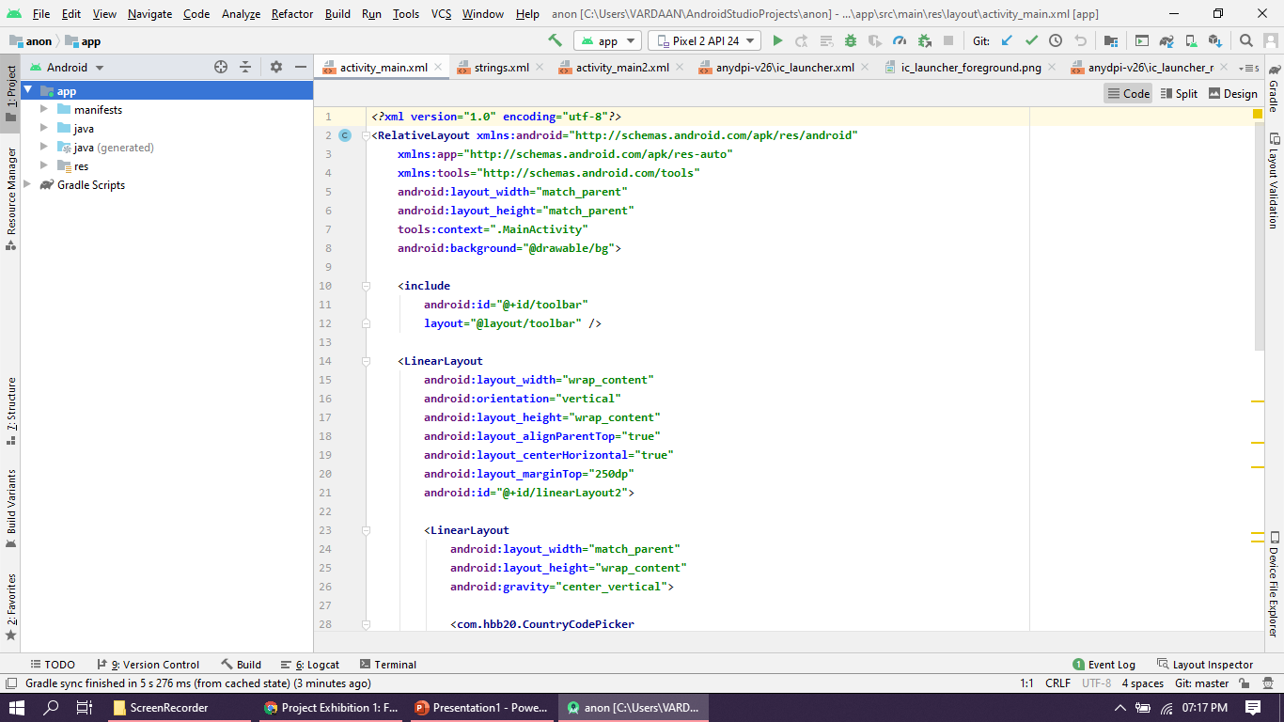

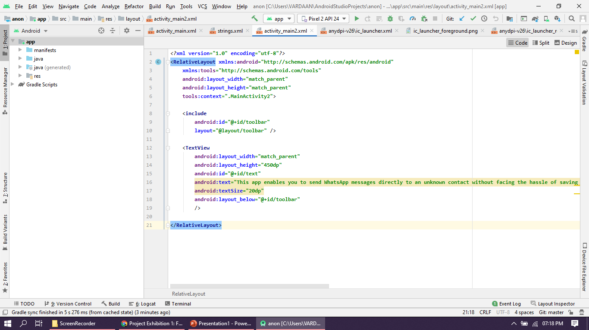

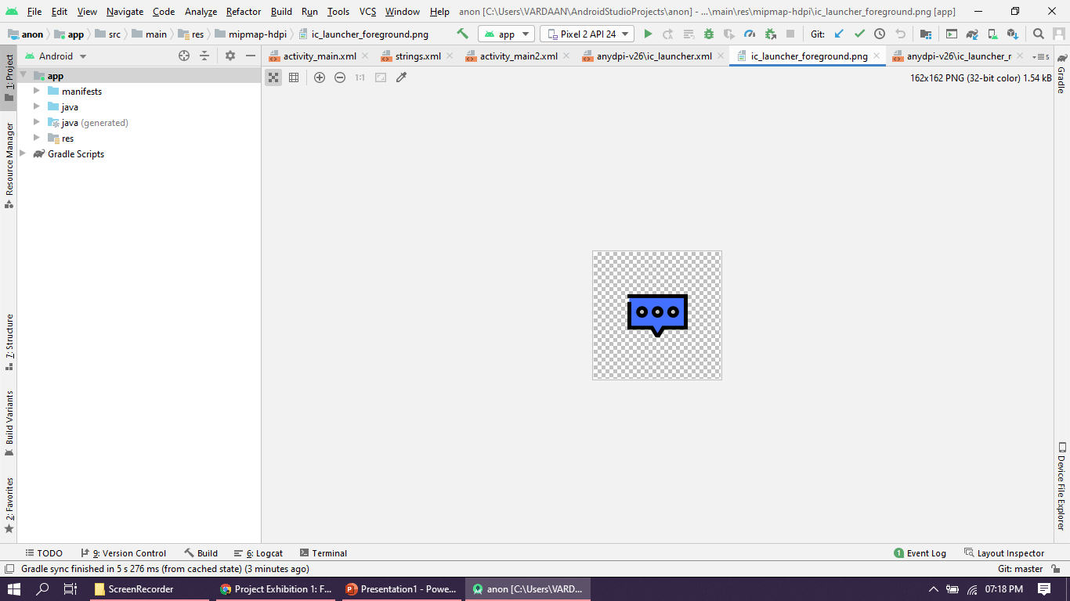

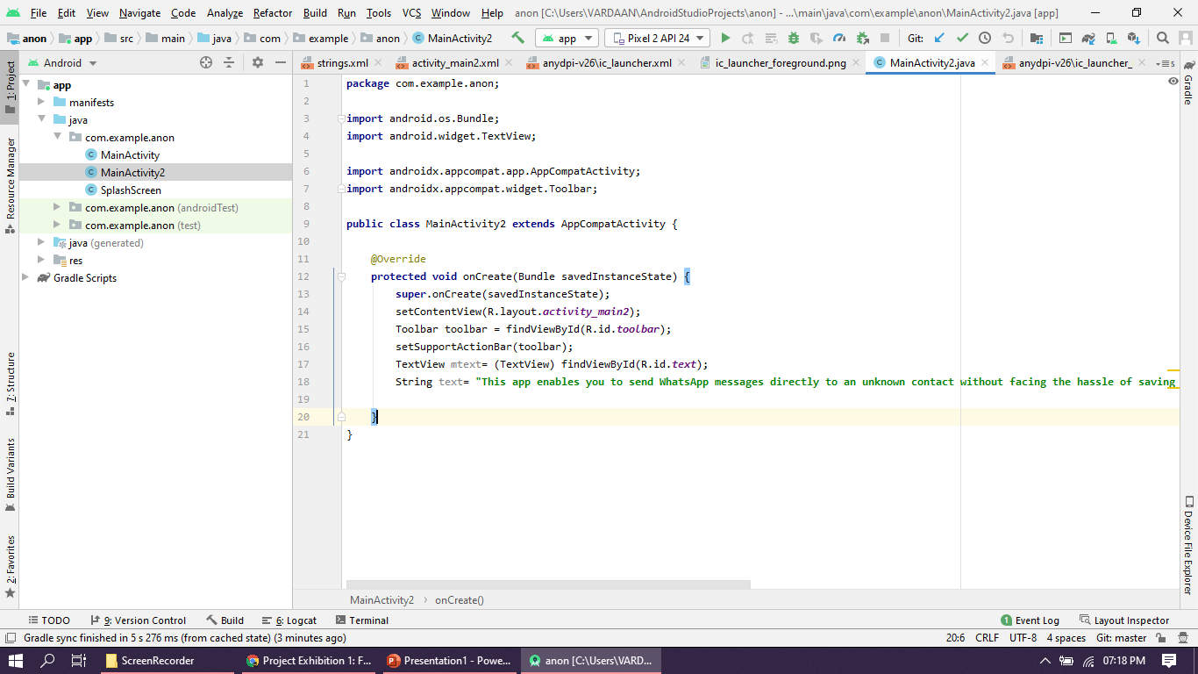

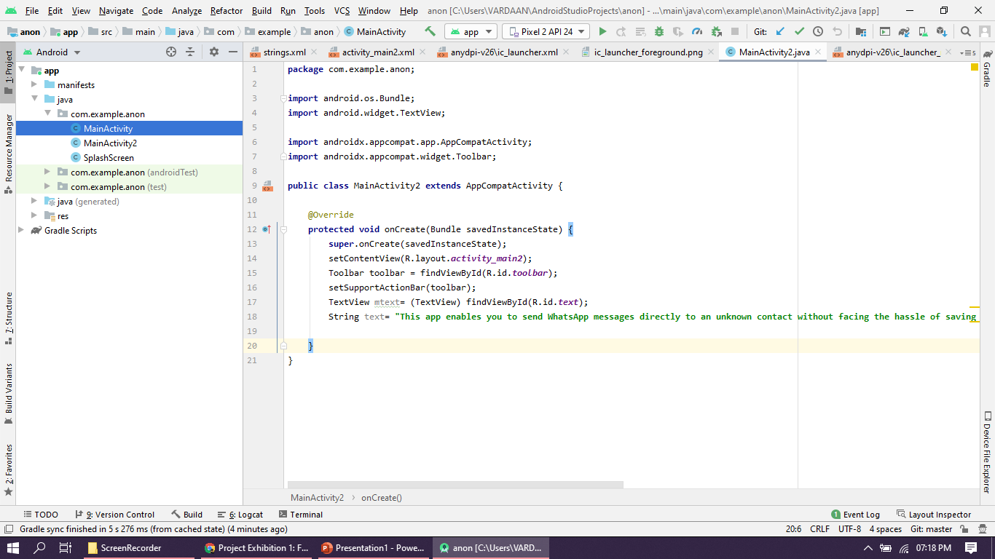

CONCLUSION

Thus, we can conclude here that ANON’s Android Native App, ANON’s Web App as well as ANON’s Website, all are functional and till now have 0 downtime to them. They all use the same API base and the team has tried to code the application modules in such a way that ANON reaches out to more and more people.

REFERENCES
- Opencv documentation
- www.darknet.com
- www.google.com

